**REST - Country Web Service**   
  
Write a REST service that returns India country details in the earlier created spring learn application.  
  
**URL**: /country  
**Controller**: com.cognizant.spring-learn.controller.CountryController  
**Method Annotation**: @RequestMapping  
**Method Name**: getCountryIndia()  
**Method Implementation**: Load India bean from spring xml configuration and return  
**Sample Request**: http://localhost:8083/country  
**Sample Response**:

{

  "code": "IN",

  "name": "India"

}

**Solution:**

**SpringLearnApplication.java:**

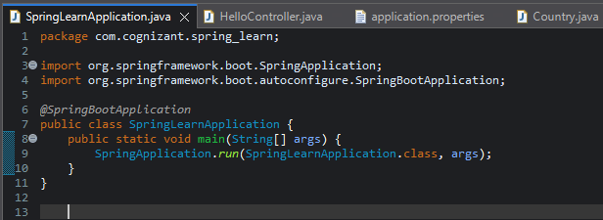

**CountryController.java**

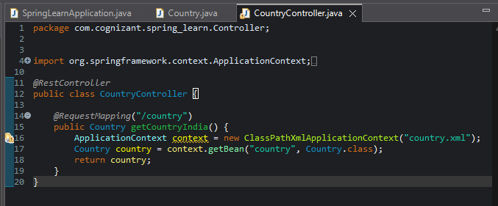

**Country class:**

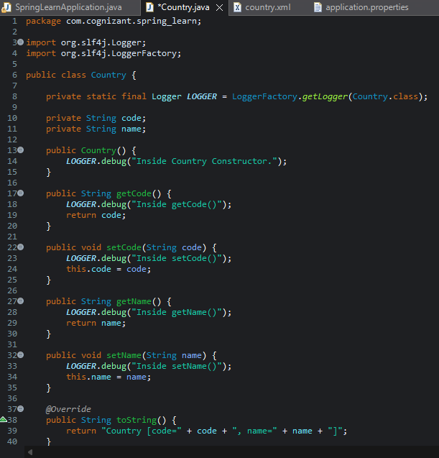

**OUTPUT:**

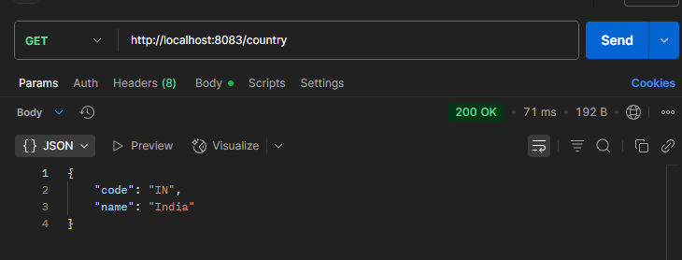

SME to explain the following aspects:

* **What happens in the controller method?**
* Spring calls getCountryIndia() when /country is requested
* It loads the Spring context from country.xml
* It fetches the country bean (code: IN, name: India)
* Returns the Country object as the response

* **How the bean is converted into JSON reponse?**

Spring Boot auto-configures Jackson (a JSON converter library)

The @RestController + return type Country triggers automatic conversion to JSON

Jackson uses getCode() and getName() methods to build the JSON

* **In network tab of developer tools show the HTTP header details received**

**In Chrome Developer Tools (Network Tab)**

1. Open browser → go to: http://localhost:8083/country
2. Press **F12** → go to **Network tab**
3. Click on /country request
4. In **Headers** tab:

**Response Headers:**

| **Key** | **Value** |
| --- | --- |
| **Status** | 200 OK |
| **Transfer-Encoding** | chunked |

* **In postman click on "Headers" tab to view the HTTP header details received**

After sending GET http://localhost:8083/country

Click **"Headers"** tab in response section

